Schull & Fitbones Summer Camp 2011
Ages 6-14
Schull, West Cork, Ireland

Application form
Name of child (children)

Age(s)

Mum’s name and mobile number
Dad’s name and mobile number
Address

Email

Any medical condition or special needs of which we should be aware?
CAMP DATES  09.30 – 14.00 | LOCATION | PLEASE TICK | PAYMENT  ATTACHED
July 4-8 | Schull & Ballydehob
July 18-22 | Schull & Ballydehob
Aug 2-5* | Schull & Ballydehob
Aug 8-12 | Schull & Ballydehob
Aug 15-19 | Schull & Ballydehob

€120 / week (extra sibling €110)

* 4 day /week @ €110 (extra sibling €100)

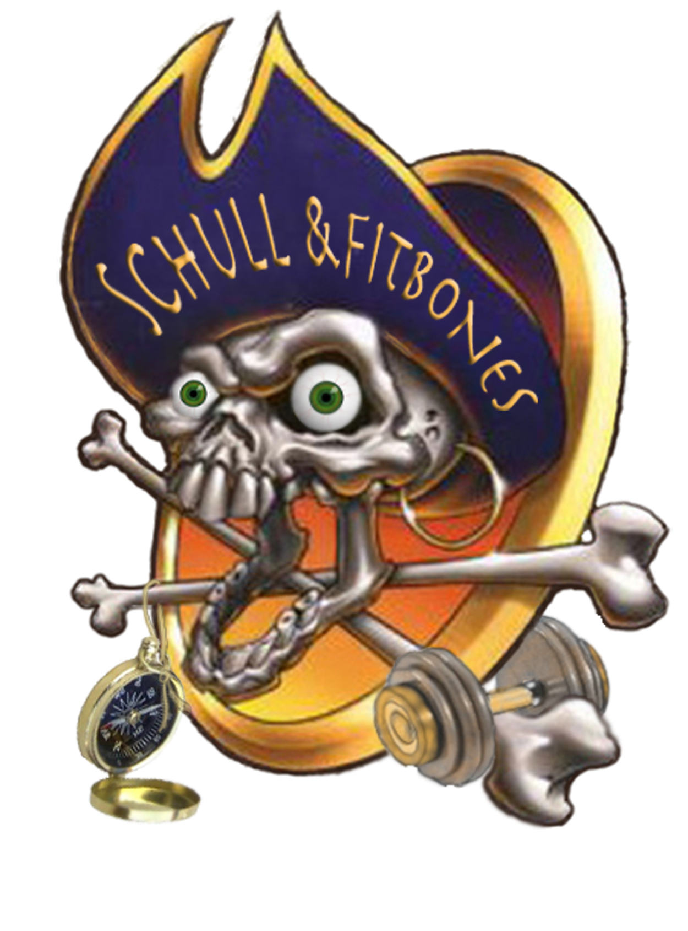
€30 for single days

€50 deposit (non-refundable) per application

Please make cheques payable to: Schull & Fitbones

Please send completed application to:
Schull & Fitbones
Castlepoint
Schull
Co. Cork
Ireland

